**Project Report**

**On**

**Online quiz platform**

**By**

**TABLE OF CONTENT**

|  |  |  |
| --- | --- | --- |
| **Sr.No** | **Content** | **Page No** |
| 1 | Introduction | 3 |
| 2 | Abstract | 4 |
| 3 | AIM of Project | 5 |
| 4 | Scope of Work | 6 |
| 5 | Administrative Model | 8 |
| 6 | Benefits of online quiz | 9 |
| 7 | Screenshots | 10 |
| 8 | Conclusion | 13 |

**Introduction**

On-line examinations contents providers to focus on creating effective assessment questions and focusing on exam's feedback delivery to students. In the paper we present techniques that are pertinent to the elements of assessment process: answers submission, computerized grading, and feedback after submission.

As the modern organizations are automated and computers are working as per the instructions, it becomes essential for the coordination of human beings, commodity and computers in a modern organization.

The administrators instructor, Students who are attending for online examination can communicate with the system through this projects, thus facilitating effective implementation and monitoring of various activities of Online Examinations like conducting Exams as per scheduled basis and delivering result to that particular use or student. And the details of students who attempted Online Examination are maintained at administrator.

1.1 Existing system and need of the system

Existing system is a manual one in which users are maintaining books to store the information like Student Details, InstructorDetails, Schedule Details and feedbacks about students who attempted exam as per schedule.. It is very difficult to maintain historical data.

**Abstract**

The client uses MS Excel, and maintains their records, however it is not possible them to share the data from multiple system in multi user environment, there is lot of duplicate work, and chance of mistake. When the records are changed they need to update each and every excel file. There is no option to find and print previous saved records. There is no security; any body can access any report and sensitive data, also no reports to summary report. This Online Quiz System is used to overcome the entire problem which they are facing currently, and making complete atomization of manual system to computerized system.

**AIM OF The Project**

The objective and scope of my Project Online Quiz System is to record the details various activities of user. It will simplifies the task and reduse the paper work. During implementation every user will be given appropriate training to suit their specific needs. Specific support will also be provided at key points within the academic calendar. Training will be provided on a timely basis, and you will be trained as the new is Online Quiz System rolled out to your area of responsibility.

At the moment we are in the very early stages, so it is difficult to put a specific time on the training, but we will keep people informed as plans are developed. The system is very user friendly and it is anticipated that functions of the system will be easily accessed by administrators, academics, students and applicants.

Hence the management system for the College management has been designed to remove all thed eficiency from which the present system is suffering and to ensure.

**Scope Of Work**

Technological advancements in this era of digitization along with being a boon to the world have been advantageous to the educational sector too. The introduction of online exam software replaced the conventional system of assessment. The various examination conducting agencies are now able to evaluate the test takers freely and cost-effectively through computer-based tests. Today's article discusses the scope and objectives of an online examination system.

Before proceeding further let us understand the concept of online examination software. Exam software allows users to take online tests and automatically generate results based on the answers marked by the users.

Lets now discuss the reasons for the introduction of online examination in the modes of conducting an assessment.

**1.Conduct exams effortless:**

Computer-based tests as a method of conducting an assessment enable users to manage an exam easily. The functionalities of an exam software such as user-friendly dashboard, multiple languages, support for multiple question types and formats, detailed reporting, automatic instant results help in smooth conduction.

**2 Reduce exam anxiety Amongst test takers:**

The flexibility associated with computer-based tests reduces exam anxiety among test takers as they can take the exam at any time of the day that coincides with their preferred sleep/ wake cycle.

**3 Promote social interaction between the test taker and experts:**

An online environment promotes exam preparation with experts or peers as they can review the course content together. Online assessment possible through exam software lays the real foundation of academic teaching as it facilitates discussion with teachers or other students.

**4 Prevents cheatings:**

Cheating amongst the test-takers in the examination hall is one of the major drawbacks of pen paper-based assessment. Online examination managed avoids the possibilities of secretly using unfair means to get the right answers. The presence of various functionalities in exam software prevents cheating irrespective of the test taker's location.

**5 Safe and secure data:**

Various tools offered by exam software have enabled the assessment conducting agencies to manage the crucial data related to examination questions and test-takers safely.

**6 Reduce administrative burden:**

Organizing and running exams online not only reduces an organization administrative burden but also saves cost and time. Online examination with its objective to make evaluation massive but simple, cost-effective and faster has replaced the pen paper-based assessment. The examination managing agencies have started preferring computer- based test to instill their lost faith in the method of conducting an evaluation. Thus online examination software offered by Pesofts is one of the most advanced software for conducting tests.

**Administrative Modules**

Here in my project modules. This module is the main module which performs all the main operations in the system. The major operations in the system are:

**User Module**

A simple user can access their test and can show the test score.

1- User login, use your name

2- Select your language you want to take a test

3- Test instructions

4- Start your test

5- After Submiting your test Score will be shown

**Benefits of online quiz**

During this pandemic, the school learning is done online. Teaching through online learning is challenging for some teachers. Teachers have to prepare a variety of methods and techniques to teach a subject that is effective during e-learning. The use of slideshow, videos, pictures, games, and online generator to create quizzes are things that teachers can use to support the teaching.

Giving online quizzes is one of the techniques that teachers can use in class. This activity helps the teachers and the students as well, to know what and how much they have understood about a subject. This technique is important to be given at the beginning or end of the class. However teachers must be mindful to choose the appropriate types of quizzes for the students. They have to consider that the quizzes are not only to know the students' comprehension toward the topic but also to make them enjoy completing the quizzes. During e-learning, teachers can try to use websites that provide ideas and templates which can help them create quizzes. Kahoot! and Quizizz are examples of web-based quizzes that teachers can use to create fun online quizzes.

As we know, young learners can easily get bored and lack focus when they study for long periods of time. In order to cope with this limitation, teachers have to design fun quizzes for their students. Unique features such as power-ups and live dashboard in Quizizz can boost their interest toward the quiz. Furthermore there are several benefits of giving online quizzes for students.

1. **Students are being actively engaged in subject material.** When students cannot answer certain questions in a quiz, they will go back to reread certain parts of the chapter. Teachers can also review questions with most incorrect answers with the students.
2. **Quizzes can increase students’ motivation.** Students would like to get higher scores during the quizzes. To make it happen, the students will pay attention to the teachers' explanation and may even review before the quiz.
3. **Quizzes can help students to recall information and get better grades**. When the quiz is set as an assignment, students can play the quiz over again by themselves. By repeating, the information will be stuck in their mind.
4. **Fun online quizzes can reduce students’ stress.** Kahoot! and Quizizz has a live dashboard with music background. Students are able to see their own and others’ rank. They can compete with other students to get higher scores. Power-ups feature in Quizizz helps students to get double points or they may also decide to erase this option. This feature makes students excited to get more power and use it. Sometimes, after they answer the questions, a meme will appear. These features make students forget that they are doing a quiz.

**ScreenShots**

1 Home page:

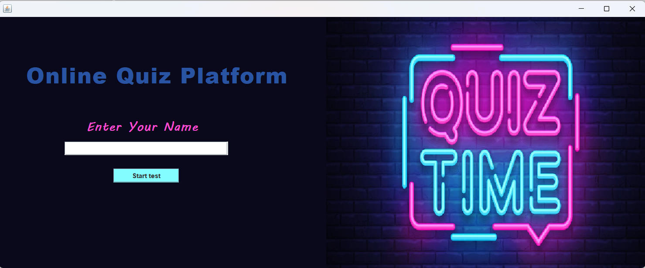

2 Quiz language Selection:

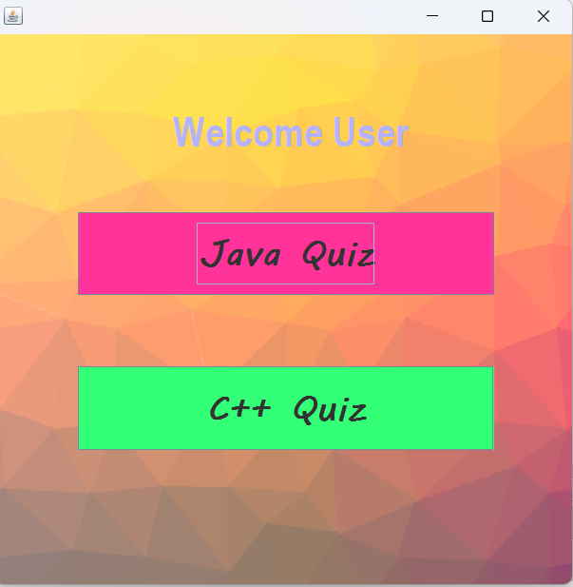

3 Quiz Instructions :

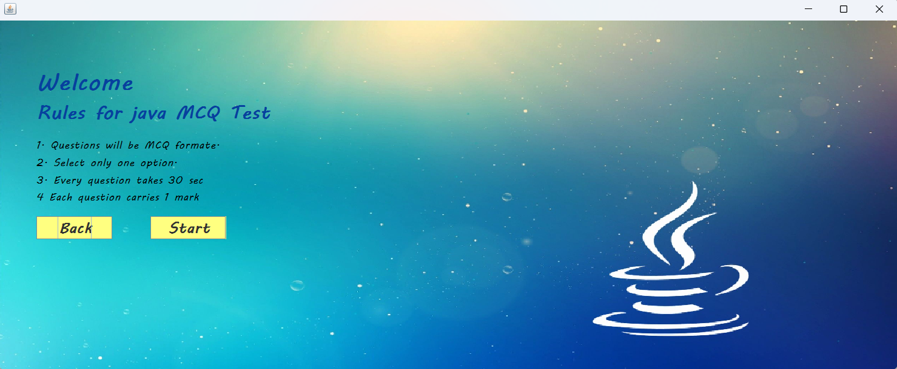

4 MCQ Questions :

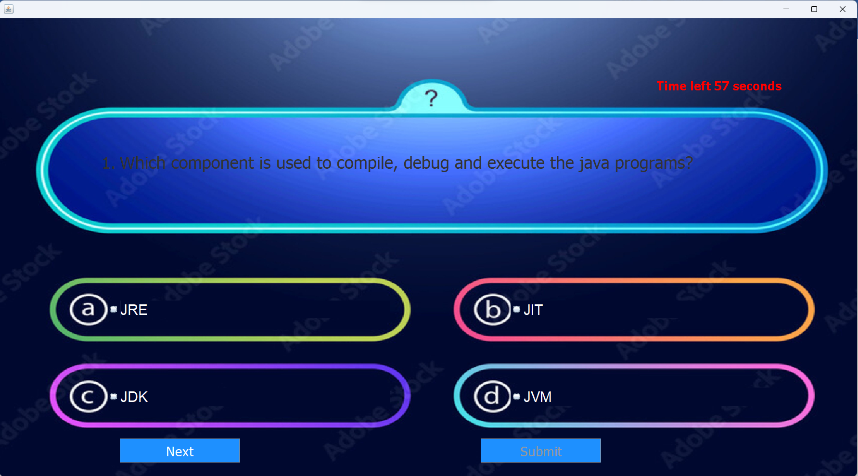

5 Test Score:

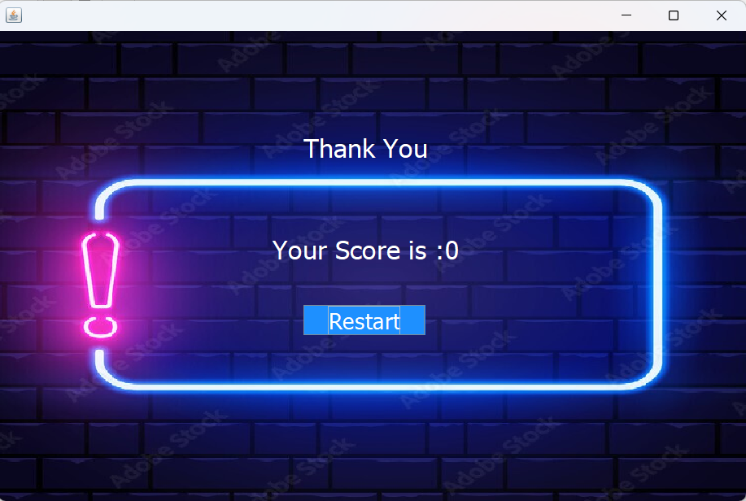

**Conclusion**

This online quiz application provides facility to play quiz anywhere and anytime. It save time since user does need to wait for result. So student/user cannot wait for the result. All Student/ user get extra knowledge and skills. Administrator has a privilege to put as much as question in any category given in application. User can register, log-in, and give the test with his/her specific id, and can see the results as well.